Stack

What is a Stack?
# Source: AI Source: Provided by: [Data Path: Persons Table -> ID Column: 1, Name_En Column: Motasem Essam] -> From: [Chatgpt (GPT‑5 Mini)] on [12/10/2025]
- A linear data structure that follows LIFO (Last In, First Out) principle.
- Only the top element is accessible at any time.
- Used for function calls, expression evaluation, undo mechanisms, backtracking.

Key Characteristics
# Source: AI Source: Provided by: [Data Path: Persons Table -> ID Column: 1, Name_En Column: Motasem Essam] -> From: [Chatgpt (GPT‑5 Mini)] on [12/10/2025]
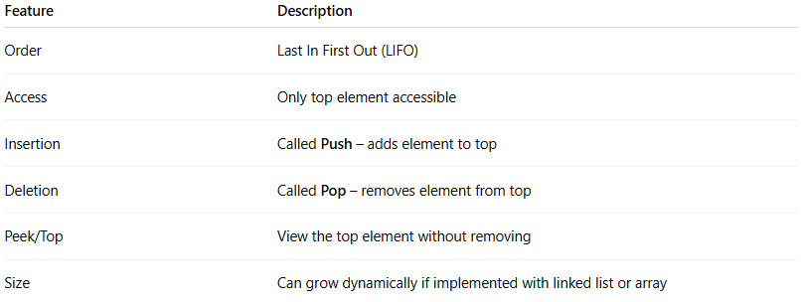
Feature | Description
Order | Last In First Out (LIFO)
Access | Only top element accessible
Insertion | Called Push – adds element to top
Deletion | Called Pop – removes element from top
Peek/Top | View the top element without removing
Size | Can grow dynamically if implemented with linked list or array

Types of Stack
- Array-Based Stack
• Stack implemented using an array.
• Fixed size unless dynamically resized.
• Elements are stored in contiguous memory locations.
• Example:
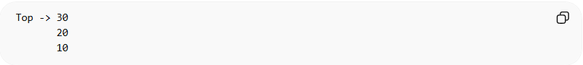
Top -> 30
20
10
- Linked List-Based Stack
• Stack implemented using a linked list.
• Dynamic size – grows and shrinks as needed.
• Each node points to the next node, top points to the last inserted node.
• Example:
Top -> 30 -> 20 -> 10 -> NULL
- Dynamic Stack (Resizable / Vector-Based)
• Stack implemented using dynamic arrays or built-in resizable structures.
• Can grow or shrink at runtime.
• Combines benefits of array and linked list stacks.
• Example in C++:
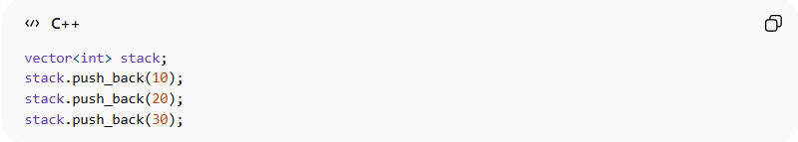
vector<int> stack;
stack.push_back(10);
stack.push_back(20);
stack.push_back(30);

Summary Table of Stack Types
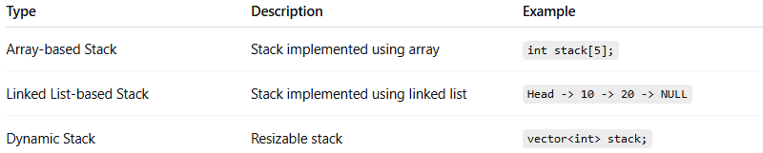
Type | Description | Example
Array-based Stack | Stack implemented using array | int stack[5];
Linked List-based Stack | Stack implemented using linked list | Head -> 10 -> 20 -> NULL
Dynamic Stack | Resizable stack | vector<int> stack;

Example of Stack
# Source: AI Source: Provided by: [Data Path: Persons Table -> ID Column: 1, Name_En Column: Motasem Essam] -> From: [Chatgpt (GPT‑5 Mini)] on [12/10/2025]
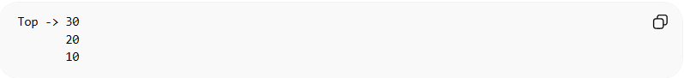
Top -> 30
20
10
- Push(40): adds 40 to top
- Pop(): removes 40 from top

Common Operations on Stack

1. Push (Adding an Element)
# Source: AI Source: Provided by: [Data Path: Persons Table -> ID Column: 1, Name_En Column: Motasem Essam] -> From: [Chatgpt (GPT‑5 Mini)] on [12/10/2025]
Definition:
Pushing means adding a new element to the top of the stack.
Stacks follow LIFO (Last In, First Out), so insertion always occurs at the top.
Example Stack (before push):
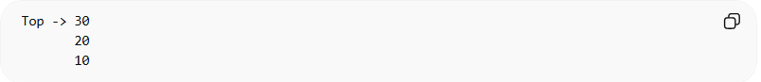
Top -> 30
20
10
Push 40:
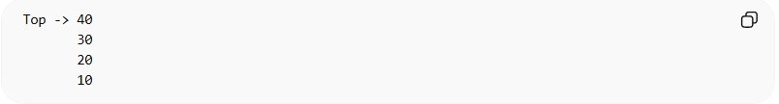
Top -> 40
30
20
10
Example in C (Array-Based Stack):
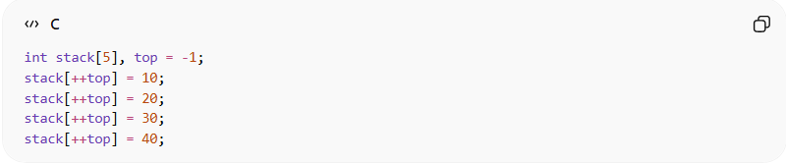
int stack[5], top = -1;
stack[++top] = 10;
stack[++top] = 20;
stack[++top] = 30;
stack[++top] = 40;
Push Time Complexity:
- Time Complexity: O(1)
- Reason: Element is always added at the top; no traversal required.

2. Pop (Removing an Element)
# Source: AI Source: Provided by: [Data Path: Persons Table -> ID Column: 1, Name_En Column: Motasem Essam] -> From: [Chatgpt (GPT‑5 Mini)] on [12/10/2025]
Definition:
Popping means removing the element from the top of the stack.
Example Stack (before pop):
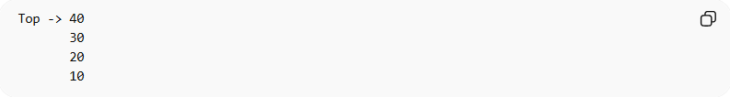
Top -> 40
30
20
10
Pop operation removes 40:
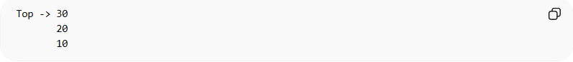
Top -> 30
20
10
Example in C (Array-Based Stack):
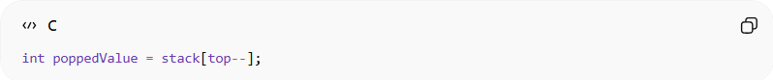
int poppedValue = stack[top--];
Pop Time Complexity:
- Time Complexity: O(1)
- Reason: Element is always removed from the top; no traversal needed.

3. Peek / Top (Reading the Top Element)
# Source: AI Source: Provided by: [Data Path: Persons Table -> ID Column: 1, Name_En Column: Motasem Essam] -> From: [Chatgpt (GPT‑5 Mini)] on [12/10/2025]
Definition:
Peek retrieves the value of the top element without removing it.
Example Stack:
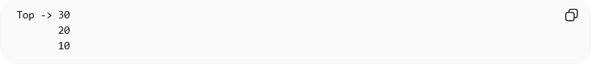
Top -> 30
20
10
Peek → returns 30, stack remains unchanged.
Example in C:
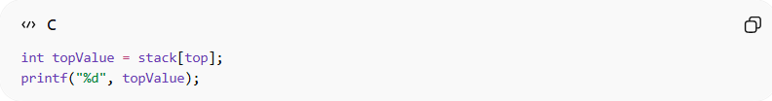
int topValue = stack[top];
printf("%d", topValue);
Peek Time Complexity:
- Time Complexity: O(1)
- Reason: Directly accesses the top element.

4. Traversal (Visiting All Elements)
# Source: AI Source: Provided by: [Data Path: Persons Table -> ID Column: 1, Name_En Column: Motasem Essam] -> From: [Chatgpt (GPT‑5 Mini)] on [12/10/2025]
Definition:
Traversal means going through each element in the stack from top to bottom.
Example Stack:
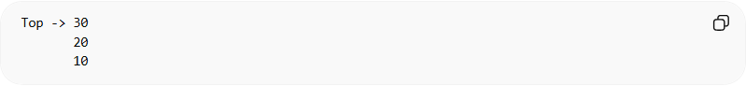
Top -> 30
20
10
Traversal prints:
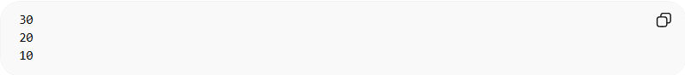
30
20
10
Example in C:
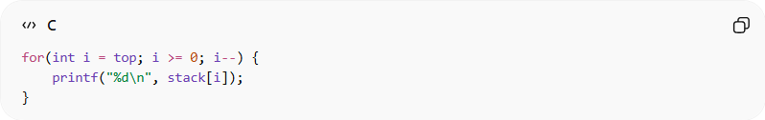
for(int i = top; i >= 0; i--) {
printf("%d\n", stack[i]);
}
Traversal Time Complexity:
- Time Complexity: O(n)
- Reason: Every element must be visited one by one.

5. Searching (Finding an Element)
# Source: AI Source: Provided by: [Data Path: Persons Table -> ID Column: 1, Name_En Column: Motasem Essam] -> From: [Chatgpt (GPT‑5 Mini)] on [12/10/2025]
Definition:
Searching means finding the position of a specific value in the stack.
Search starts from the top because stack access is LIFO.
Example Stack:
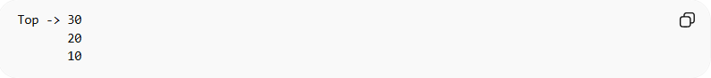
Top -> 30
20
10
Search for 20 → position 1 from the top.
Example in C:
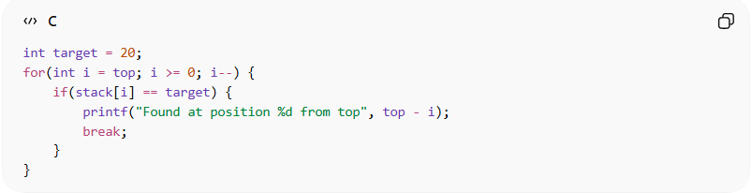
int target = 20;
for(int i = top; i >= 0; i--) {
if(stack[i] == target) {
printf("Found at position %d from top", top - i);
break;
}
}
Search Time Complexity:
- Time Complexity: O(n)
- Reason: Must check each element until the target is found.

Summary of Stack Operations
# Source: AI Source: Provided by: [Data Path: Persons Table -> ID Column: 1, Name_En Column: Motasem Essam] -> From: [Chatgpt (GPT‑5 Mini)] on [12/10/2025]
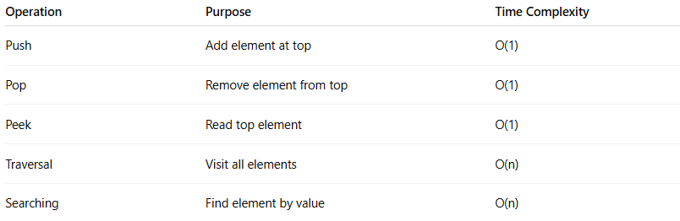
Operation | Purpose | Time Complexity
Push | Add element at top | O(1)
Pop | Remove element from top | O(1)
Peek | Read top element | O(1)
Traversal | Visit all elements | O(n)
Searching | Find element by value | O(n)

Example in C (Array-based Stack)
# Source: AI Source: Provided by: [Data Path: Persons Table -> ID Column: 1, Name_En Column: Motasem Essam] -> From: [Chatgpt (GPT‑5 Mini)] on [12/10/2025]
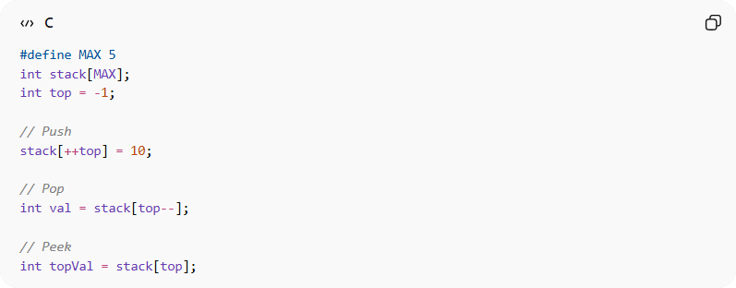
#define MAX 5
int stack[MAX];
int top = -1;

// Push
stack[++top] = 10;

// Pop
int val = stack[top--];

// Peek
int topVal = stack[top];

Real-World Examples
# Source: AI Source: Provided by: [Data Path: Persons Table -> ID Column: 1, Name_En Column: Motasem Essam] -> From: [Chatgpt (GPT‑5 Mini)] on [12/10/2025]
- Browser back button
- Undo feature in text editors
- Call stack in programming languages
- Expression evaluation (postfix, prefix)

Advantages
# Source: AI Source: Provided by: [Data Path: Persons Table -> ID Column: 1, Name_En Column: Motasem Essam] -> From: [Chatgpt (GPT‑5 Mini)] on [12/10/2025]
- Simple and easy to implement
- Fast insertion and deletion (O(1))
- Helps solve problems using LIFO logic

Disadvantages
# Source: AI Source: Provided by: [Data Path: Persons Table -> ID Column: 1, Name_En Column: Motasem Essam] -> From: [Chatgpt (GPT‑5 Mini)] on [12/10/2025]
- Fixed size in array-based implementation
- Only top element accessible
- Traversal is slower (if you need all elements)

